# Code

## Site Hosted at: <http://richhildebrand.github.io/Jason-Kipnis/lineGraph.html>

## Repository at: <https://github.com/richhildebrand/Jason-Kipnis>

Additionally the code can be run locally if you turn off CORS concerns on chrome.

chrome --disable-web-security

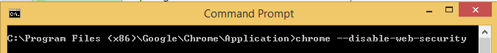

# Technologies used

## RequireJS

Loads JavaScript files on demand to allow modularization.

Site: <http://requirejs.org/>

### Example Use:

### 

## RequireJS text plugin

Allows RequireJS to load text on demand as well as javaScript.

### Site: <https://github.com/requirejs/text>

### Example Use:

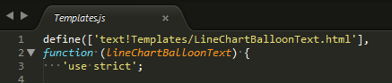

## Kendo

Used for MVVM bindings and widgets such as the multi select and dropdown list.

### Site: <http://demos.telerik.com/kendo-ui/>

### Example Use:

### 

## amCharts

Used for rendering Graphs.

### Site: <http://www.amcharts.com/javascript-charts/>

### Example Use:

